**ONLINE LAPTOP APPLICATION**

# A Mini Project Report Submitted by

**SOWMIYA S**

## 21CSR198

***in partial fulfillment of the requirements for the award of the degree of***

**BACHELOR OF ENGINEERING IN**

**COMPUTER SCIENCE AND ENGINEERING**

# DEPARTMENT OF COMPUTER SCIENCE AND ENGINEERING



**KONGU ENGINEERING COLLEGE**

**(Autonomous)**

# PERUNDURAI ERODE-638060

**MAY 2023**

**AIM:**

To develop a online laptop application using HTML, CSS, Bootstrap, JavaScript along

with database connectivity.

**PROCEDURE:**

**Login.html:**

<!DOCTYPE html>

<html>

<head>

<meta charset="utf-8">

<meta name="viewport" content="width=device-width, initial-scale=1">

<link href="https://cdn.jsdelivr.net/npm/bootstrap@5.2.3/dist/css/bootstrap.min.css" rel="stylesheet">

<script src="https://cdn.jsdelivr.net/npm/bootstrap@5.2.3/dist/js/bootstrap.bundle.min.js"></script>

<link rel="stylesheet" type="text/css" href="styles/login.css">

<style>

body

{

background-image: url("assets/b1.jfif");

background-repeat: no-repeat;

background-size: 100% 1000px;

}

</style>

</head>

<body>

<nav class="navbar navbar-expand-sm navbar-dark bg-dark">

<div class="container-fluid">

<button class="navbar-toggler" type="button" data-bs-toggle="collapse" data-bs-target="#collapsibleNavbar">

<span class="navbar-toggler-icon"></span>

</button>

<div class="collapse navbar-collapse" id="collapsibleNavbar">

<ul class="navbar-nav me-auto">

<li class="nav-item">

<a class="nav-link" href="login.html" style="color:white;"><H5>Home</H5></a>

</li>

<a class="nav-link" href="login.html" style="color:white;"><H5>Login</H5></a>

</li>

<li class="nav-item">

<a class="nav-link" href="register.html" style="color:white;"><H5>Register</H5></a>

</li>

<li class="nav-item">

<a class="nav-link" href="abouts.html" style="color:white;"><H5>About us</H5></a>

</li>

<li class="nav-item">

</ul>

</div>

</div>

</div>

</nav>

<br>

<div class="container-fluid">

<div class="row">

<div class="col-md-8">

<div class="welcome">

<h1 style="color:white; text-align: center;">Welcome to our website!!<br>Sign up now & enjoy ur first purchase</h1><br>

<h5 style="color: white; text-align: center;">You can visit our laptops here</h5>

</div>

</div>

<div class="col-md-4">

<div class="f">

<div class="hello">

<center><h1>Login</h1></center>

</div>

<table><div class="user">

<tr><td>

<label> Name</label></td>

<td><input type="text" name="name" id="name" placeholder="Enter your name" required></td></tr>

<br><br>

<tr><td>

<label> Password</label></td>

<td><input type="text" name="password" id="password" placeholder="Enter your password" required></td></tr></div>

</table>

<br><br>

<center><a href="products.html"><button type="button" class="btn btn-primary">Login</button></a>

<a href=" "><button type="button" class="btn btn-primary">Forgot password</button></a></center><br>

<br><center>If there is no account <a href="register.html">Register here</a><br><br></center>

</div>

</div>

</div>

</div>

</body>

</html>

**Register.html:**

<!DOCTYPE html>

<html>

<head>

<meta charset="utf-8">

<meta name="viewport" content="width=device-width, initial-scale=1">

<link href="https://cdn.jsdelivr.net/npm/bootstrap@5.2.3/dist/css/bootstrap.min.css" rel="stylesheet">

<script src="https://cdn.jsdelivr.net/npm/bootstrap@5.2.3/dist/js/bootstrap.bundle.min.js"></script>

<link rel="stylesheet" type="text/css" href="styles/register.css">

<style>

<body>

{

background-color: aliceblue;

}

</style>

</head>

<script type="text/javascript">

window.addEventListener("load",start,false);

function moveone(){

document.getElementById("move").innerHTML="Registration Form";

}

function start()

{ document.getElementById("move").addEventListener("mousemove",moveone,false);

document.getElementById("picture").addEventListener("mouseover",over,false);

document.getElementById("picture").addEventListener("mouseout",out,false);

}

function over(e) {

document.getElementById("picture").setAttribute("src","assets/b1.jfif");

}

function out(e) {

e.target.setAttribute("src","assets/l4.jpg");

}

function myFunction(x) {

x.style.background = "lightgray";

}

function blurFunction(x){

x.style.background="lavender";

}

function create_account(){

var n=document.getElementById("name").value;

var e=document.getElementById("email").value;

var a=document.getElementById("address").value;

var dob=document.getElementById("dob").value;

var mob=document.getElementById("mob").value;

var p=document.getElementById("password").value;

var cp=document.getElementById("confirm").value;

var letters = /^[A-Za-z]+$/;

var email_val = /^([a-zA-Z0-9_\.\-])+\@(([a-zA-Z0-9\-])+\.)+([a-zA-Z0-9]{2,4})+$/;

if(n==''||e==''||a==''||dob==''||mob==''||p==''||cp==''){

alert("Enter each details correctly");

}

else if(!letters.test(n))

{

alert('Name is incorrect must contain alphabets only');

}

else if (!email_val.test(e))

{

alert('Invalid email format please enter valid email id');

}

else if(p!=cp)

{

alert("Passwords not matching");

}

else if(document.getElementById("password").value.length > 12)

{

alert("Password maximum length is 12");

}

else if(document.getElementById("password").value.length < 6)

{

alert("Password minimum length is 6");

}

else{

alert("Your account has been created successfully...");

window.location="file:///E:/web-laptop/login.html";

}

}

</script>

<body>

<nav class="navbar navbar-expand-sm navbar-dark bg-dark">

<div class="container-fluid">

<button class="navbar-toggler" type="button" data-bs-toggle="collapse" data-bs-target="#collapsibleNavbar">

<span class="navbar-toggler-icon"></span>

</button>

<div class="collapse navbar-collapse" id="collapsibleNavbar">

<ul class="navbar-nav me-auto">

<li class="nav-item">

<a class="nav-link" href="login.html" style="color:white;"><H5>Home</H5></a>

</li>

<a class="nav-link" href="login.html" style="color:white;"><H5>Login</H5></a>

</li>

<li class="nav-item">

<a class="nav-link" href="products.html" style="color:white;"><H5>Laptop</H5> </a>

</li>

<li class="nav-item">

<a class="nav-link" href="abouts.html" style="color:white;"><H5>About us</H5></a>

</li>

<li class="nav-item">

</ul>

</div>

</div>

</div>

</nav>

<br>

<div class="container-fluid">

<div class="row">

<div class="col-md-7">

<div class="img-responsive"><br><br><br>

<img src="assets/l4.jpg" id="picture" alt="" class="img-thumbnail" ></div>

</div>

<div class="col-md-5">

<div class="f">

<div class="hello">

<center><h1 id="move">Register</h1></center>

</div><br>

<form>

<table cellspacing="2" align="center" cellpadding="8" border="0">

<tr><td> Name</td>

<td><input type="text" placeholder="Enter your name" name="name" id="name" onfocus="myFunction(this)" onblur="blurFunction(this)"></td></tr>

<tr><td>Email</td>

<td><input type="text" placeholder="Enter your email id" name="email" id="email" onfocus="myFunction(this)" onblur="blurFunction(this)"></td></tr>

<tr><td>Address</td>

<td><input type="text" placeholder="Enter your Address" name="address" id="address" onfocus="myFunction(this)" onblur="blurFunction(this)"></td></tr>

<tr><td>Date of birth</td>

<td><input type="date" name="dob" id="dob" onfocus="myFunction(this)" onblur="blurFunction(this)"></td></tr>

<tr><td>Mobile number</td>

<td><input type="text" placeholder="Enter your mobile number" name="mob" id="mob" onfocus="myFunction(this)" onblur="blurFunction(this)"></td></tr>

<tr><td> Set Password</td>

<td><input type="password" placeholder="Set a password" name="password" id="password" onfocus="myFunction(this)" onblur="blurFunction(this)"></td></tr>

<tr><td>Conform Password</td>

<td><input type="password" placeholder="Confirm your password" id="confirm" onfocus="myFunction(this)" onblur="blurFunction(this)"></td></tr>

<tr><td>

</table>

<center><button type="button" class="btn btn-primary" onClick="create_account()">Submit</button></center>

</form>

</div>

</div>

</div>

</div>

</body>

</html>

**About.html**

<!DOCTYPE html>

<html lang="en">

<head>

<meta charset="UTF-8">

<meta http-equiv="X-UA-Compatible" content="IE=edge">

<meta name="viewport" content="width=device-width, initial-scale=1.0">

<link rel="stylesheet" href="styles/about.css">

<title>Document</title>

</head>

<body>

<div class="bool">

<center> <img src="assets/fs.jpg" alt="" height="400px" width="80%"></center>

</div>

<br><br>

<div class="hel"><h1>About Us</h1></div>

<div class="msg">

<p>This website provides easy interface to customer for purchasing laptops online. You can also send us email and call us

on Week days. <br>Thank you for your patience and hope you had a great shopping here.</p>

</div>

<div class="contact">

<br>

<p>EMAIL ID:laptop@gmail.com</p>

<p>CONTACT NO:+91 9876543210</p>

</div>

</body>

</html>

**Dellview.html**

<!DOCTYPE html>

<html>

<head>

<meta charset="utf-8">

<meta name="viewport" content="width=device-width, initial-scale=1">

<link href="https://cdn.jsdelivr.net/npm/bootstrap@5.2.3/dist/css/bootstrap.min.css" rel="stylesheet">

<script src="https://cdn.jsdelivr.net/npm/bootstrap@5.2.3/dist/js/bootstrap.bundle.min.js"></script>

</head>

<body>

<div class="container-fluid">

<div class="row">

<div class="col-md-5 col-md-offset-1">

<div class="img-responsive"><br><br><br>

<img src="assets/l1.jfif" alt="" class="img-thumbnail" ></div>

</div>

<div class=" col-md-6 ">

<div class="hello"><br>

<center><h2>DELL lap</h2></center><br>

<p><b>Price : 49,990.00</b></p>

</div>

<hr>

<b>Processor</b> <br>

12th Gen Intel® Core™ i3-1215U (10 MB cache, 6 cores, 8 threads, up to 4.40 GHz Turbo)

<br><hr>

<b>Operating System </b> <br>

Windows 11

<br><hr>

<b>Memory</b> <br>

8 GB, 1 x 8 GB, DDR4, 3200 MHz

<br><hr>

<b>Hard Drive</b> <br>

512 GB, M.2, PCIe NVMe, SSD

<br><hr>

<b>Battery</b> <br>

4 Cell, 54 Wh, integrated

<br><hr>

<b>Camera</b><br>

1080p at 30 fps FHD camera

<br><hr>

<br><br>

<center><a href="order.html"><button type="button" class="btn btn-primary">Buy Now</button></a></center>

</div>

</div>

</div>

</body>

</html>

**Hpview.html**

<!DOCTYPE html>

<html>

<head>

<meta charset="utf-8">

<meta name="viewport" content="width=device-width, initial-scale=1">

<link href="https://cdn.jsdelivr.net/npm/bootstrap@5.2.3/dist/css/bootstrap.min.css" rel="stylesheet">

<script src="https://cdn.jsdelivr.net/npm/bootstrap@5.2.3/dist/js/bootstrap.bundle.min.js"></script>

</head>

<body>

<div class="container-fluid">

<div class="row">

<div class="col-md-5 col-md-offset-1">

<div class="img-responsive"><br><br><br>

<img src="assets/l1.jfif" alt="" class="img-thumbnail" ></div>

</div>

<div class=" col-md-6 ">

<div class="hello"><br>

<center><h2>HP lap</h2></center>

<br>

<p><b>Price : 47,990.00</b></p>

</div>

<hr>

<b>Processor</b> <br>

Intel® Core™ i5-1035G1 (1.0 GHz base frequency, up to 3.6 GHz with Intel® Turbo Boost Technology, 6 MB L3 cache, 4 cores)

<br><hr>

<b>Operating System </b> <br>

Windows 11

<br><hr>

<b>Memory</b> <br>

8 GB DDR4-2666 SDRAM (1 x 8 GB)

<br><hr>

<b>Hard Drive</b> <br>

256 GB PCIe® NVMe™ M.2 SSD

<br><hr>

<b>Battery</b> <br>

3-cell, 41 Wh Li-ion,Up to 9 hours and 15 minutes

<br><hr>

<b>Camera</b><br>

HP TrueVision 720p HD camera

<br><hr>

<br><br>

<center><a href="order.html"><button type="button" class="btn btn-primary">Order</button></a></center>

</div>

</div>

</div>

</body>

</html>

**Lenovoview.html**

<!DOCTYPE html>

<html>

<head>

<meta charset="utf-8">

<meta name="viewport" content="width=device-width, initial-scale=1">

<link href="https://cdn.jsdelivr.net/npm/bootstrap@5.2.3/dist/css/bootstrap.min.css" rel="stylesheet">

<script src="https://cdn.jsdelivr.net/npm/bootstrap@5.2.3/dist/js/bootstrap.bundle.min.js"></script>

</head>

<body>

<div class="container-fluid">

<div class="row">

<div class="col-md-5 col-md-offset-1">

<div class="img-responsive"><br><br><br>

<img src="assets/l1.jfif" alt="" class="img-thumbnail" ></div>

</div>

<div class=" col-md-6 ">

<div class="hello"><br>

<center><h2>Lenovo lap</h2></center><br>

<p><b>Price : 64,490.00</b></p>

</div>

<hr>

<b>Processor</b> <br>

11th Generation Intel® Core™ i5-1135G7 Processor (2.40 GHz up to 4.20 GHz)

<br><hr>

<b>Operating System </b> <br>

Windows 10 Pro 64

<br><hr>

<b>Memory</b> <br>

8 GB SDRAM DDR4 3200MHz

<br><hr>

<b>Hard Drive</b> <br>

1 TB 5400 HDD

<br><hr>

<b>Battery</b> <br>

3 cell, 45Wh, Upto 6 hours

<br><hr>

<b>Camera</b><br>

720p HD with PrivacyShutter

<br><hr>

<br><br>

<center><a href="order.html"><button type="button" class="btn btn-primary">Order</button></a></center>

</div>

</div>

</div>

</body>

</html>

**Products.html**

<!DOCTYPE html>

<html>

<head>

<meta name="viewport" content="width=device-width, initial-scale=1">

<link rel="stylesheet" href="https://maxcdn.bootstrapcdn.com/bootstrap/3.4.1/css/bootstrap.min.css">

<link rel="stylesheet" type="text/css" href="styles/products.css">

</head>

<body style="background-color:aliceblue">

<h1 align="center" color="brown">PRODUCTS</h1>

<br><br>

<div class="container">

<div class="row">

<div class="col-md-4"><a href="hpview.html"><img src="assets/hp1.png" alt="" class="img-thumbnail"><br></a> price:47,990.00</div>

<div class="col-md-4"><a href="hpview.html"><img src="assets/hp2.png" alt="" class="img-thumbnail"><br></a> price:54,990.00</div>

<div class="col-md-4"><a href="hpview.html"><img src="assets/hp3.png" alt="" class="img-thumbnail"><br></a> price:57,499.00</div>

</div>

<br>

<div class="row">

<div class="col-md-4"><a href="lenovoview.html"><img src="assets/le1.png" alt="" class="img-thumbnail"><br></a> price:64,490.00</div>

<div class="col-md-4"><a href="lenovoview.html"><img src="assets/le2.png" alt="" class="img-thumbnail"><br></a> price:65,490.00</div>

<div class="col-md-4"><a href="lenovoview.html"><img src="assets/le3.png" alt="" class="img-thumbnail"><br></a> price:63,490.00</div>

</div>

<br>

<div class="row">

<div class="col-md-4"><a href="dellview.html"><img src="assets/d1.png" alt="" class="img-thumbnail"><br></a> price:47,990.00</div>

<div class="col-md-4"><a href="dellview.html"><img src="assets/d2.png" alt="" class="img-thumbnail"><br></a> price:49,990.00</div>

<div class="col-md-4"><a href="dellview.html"><img src="assets/d3.png" alt="" class="img-thumbnail"><br></a> price:48,990.00</div>

</div>

</div>

</body>

</html>

**Order.html**

<!DOCTYPE html>

<html lang="en">

<head>

<title> order</title>

<meta charset="utf-8">

<meta name="viewport" content="width=device-width, initial-scale=1">

<link rel="stylesheet" href="https://cdn.jsdelivr.net/npm/bootstrap@4.6.2/dist/css/bootstrap.min.css">

<link rel="stylesheet" type="text/css" href="styles/order.css">

</head>

<body style="background-color:whitesmoke;">

<div class="container">

<centre><div class="hello">

<div class="col-md-10">

<h1 style=" color: blue; "> <center>Register your details</center> </h1>

<form id="form">

<table>

<tr><td><label> Name</label></td>

<td><input type="text" class="form-control" name="text" id="fname" placeholder="Enter your name" required></td></tr>

<tr><td><label for="email">Email</label></td>

<td><input type="email" class="form-control" id="email" placeholder="Enter your email" name="email" required></td></tr>

<tr><td><label>Mobile no</label></td>

<td><input type="text" class="form-control" required></td></tr>

<tr><td><label>Gender</label></td>

<td>

<input type="radio" id="male" name="gender" value="m">

<label> Male</label>

<input type="radio" id="female" name="gender" value="f">

<label> Female</label><br></td></tr>

<label>

<tr><td> Address

</td>

<td>

<textarea name="address" id="help" class="form-control" cols="120" rows="3" required></textarea>

</label></td></tr><br>

<tr><td> <label>Date of Birth</td>

<td><input type="date" class="form-control" name="birthDate" required></label></td></tr>

<tr><td> <label>Laptop Type</td>

<td><br>

<select name="Pack Type" class="custom-select" required>

<option>None</option>

<option>HP</option>

<option>DELL</option>

<option>Lenovo</option>

</select>

</label><br><br></td></tr>

</table>

<div class="checkbox">

<label><input type="checkbox" name="remember"> Remember me</label>

</div>

<center><button type="button" class="btn" onclick="openPopup()">Submit</button>

<div class="popup" id="popup">

<img src="assets/crt.png">

<h2>Thank You!</h2>

<p>Your details has been successfully submitted. Thanks!</p>

<button type="button" onclick="closePopup()">OK</button>

<script>

let popup=document.getElementById("popup");

function openPopup(){

popup.classList.add("open-popup");

}

function closePopup(){

popup.classList.remove("open-popup");

}

</script>

</div>

</form>

</div>

</div></centre>

</div>

</body>

</html>

**Database.js**

const express = require("express");

const bodyParser = require("body-parser");

const mongoose = require("mongoose");

const app = express();

mongoose.connect("mongodb://127.0.0.1:27017/laptopapp");

const contactSchema = new mongoose.Schema({

name: String,

email: String,

address: String,

dob: String,

mob: String,

password: String,

});

app.use(bodyParser.urlencoded({ extended: true }));

// app.use(express.static("public"));

app.get("/", function (req, res) {

res.sendFile(__dirname + "/reg1.html");

});

app.post("/", function (req, res) {

var Name = req.body.name;

var Email = req.body.email;

var Address = req.body.address;

var Dob = req.body.dob;

var Mobileno = req.body.mob;

var Password = req.body.password;

const Contact = mongoose.model("Contact", contactSchema);

const contact = new Contact({

name: Name,

email: Email,

address: Address,

dob: Dob,

mob: Mobileno,

password: Password,

});

contact.save();

console.log("success fully saved");

});

app.listen(3000);

**Login.css**

.hello {

font-size: 14;

font-family:Arial, Helvetica, sans-serif;

color: rgb(45, 73, 186);

}

.user {

font-size: 150%;

font-family:Arial, Helvetica, sans-serif;

}

.welcome{

margin-top: 4cm;

}

.f{

margin-top: 4cm;

margin-right: 1cm;

margin-left: 1cm;

background-color: lavender;

}

table {

border-collapse: collapse;

}

th, td {

padding: 15px;

}

**Register.css**

.f{

margin-top: 4cm;

margin-right: 1cm;

margin-left: 1cm;

background-color: lavender;

}

.hello {

font-size: 14;

font-family: Arial, Helvetica, sans-serif;

color: rgb(148, 24, 197);

}

.img-thumbnail {

margin-top: 1cm;

height: 100%;

}

.welcome{

margin-top: 5cm;

}

**About.css**

.hel {

text-align: center;

font-family: Cambria, Cochin, Georgia, Times, 'Times New Roman', serif;

}

.msg {

text-align: center;

font-size: 20px;

font-family: Arial, Helvetica, sans-serif;}

.contact {

text-align: center;

font-size: 20px;

font-family: Arial, Helvetica, sans-serif;

}

**Products.css**

.img-thumbnail {

margin-top: 1cm;

height: 50%;

width: 50%;

}

**Order.css**

table {

border-collapse: collapse;

}

th, td {

padding: 15px;

}

.hello {

margin-top: 4cm;

margin-right: 3cm;

margin-left: 3cm;

background-color: lavender;

}

.button {

margin-left: 1.5cm;

background-color: rgb(61, 11, 212);

border: none;

color:white;

font-size: 20px;

height: 1cm;

width: 3cm;

}

.btn{

padding: 10px 60px;

background: rgb(61, 11, 212);

border: 0;

color: white;

outline: none;

cursor: pointer;

font-size: 22px;

font-weight: 500;

border-radius: 30px;

}

.popup{

width: 400px;

background: #fff;

border-radius: 6px;

position: absolute;

top: 0;

left: 50%;

transform: translate(-50%,-50%) scale(0.1);

text-align: center;

padding: 0 30px 30px;

color: #333;

visibility: hidden;

transition: transform 0.4s, top 0.4s;

}

.open-popup{

visibility: visible;

top: 50%;

transform: translate(-50%,-50%) scale(1);

}

.popup img{

width: 100px;

margin-top: -50px;

border-radius: 50%;

box-shadow: 0 2px 5px rgba(0,0,0,0.2);

}

.popup h2{

font-size: 38px;

font-weight: 500;

margin: 30px 0 10px;

}

.popup button{

width: 100%;

margin-top: 50px;

padding: 10px 0;

background: #6fd649;

color: #fff;

border: 0;

outline: none;

font-size: 18px;

border-radius: 4px;

cursor: pointer;

box-shadow: 0 5px 5px rgba(0,0,0,0.2);

}

# Output

Fig.1.Home and Login page

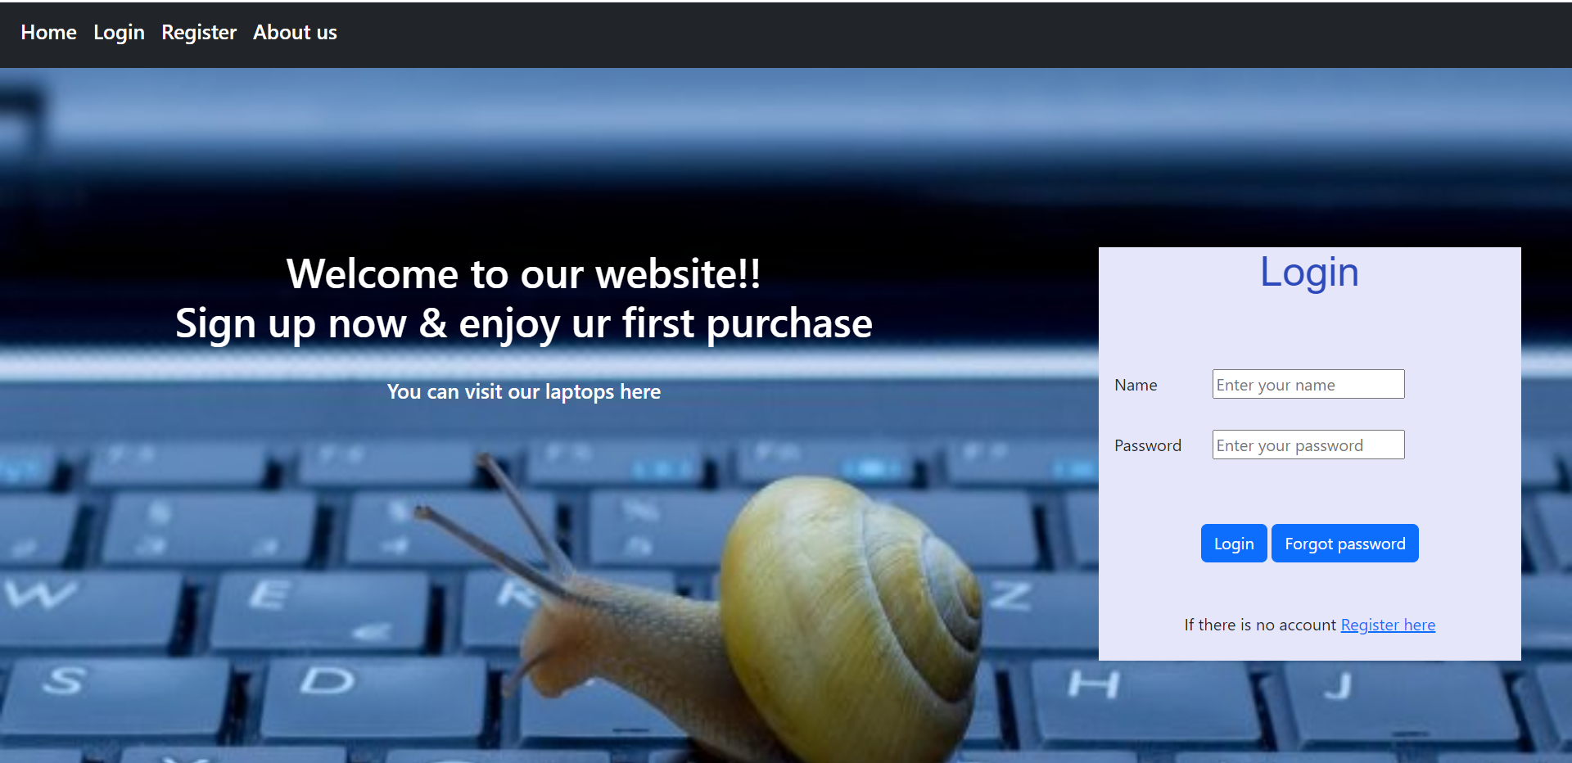

Fig.2.Register page

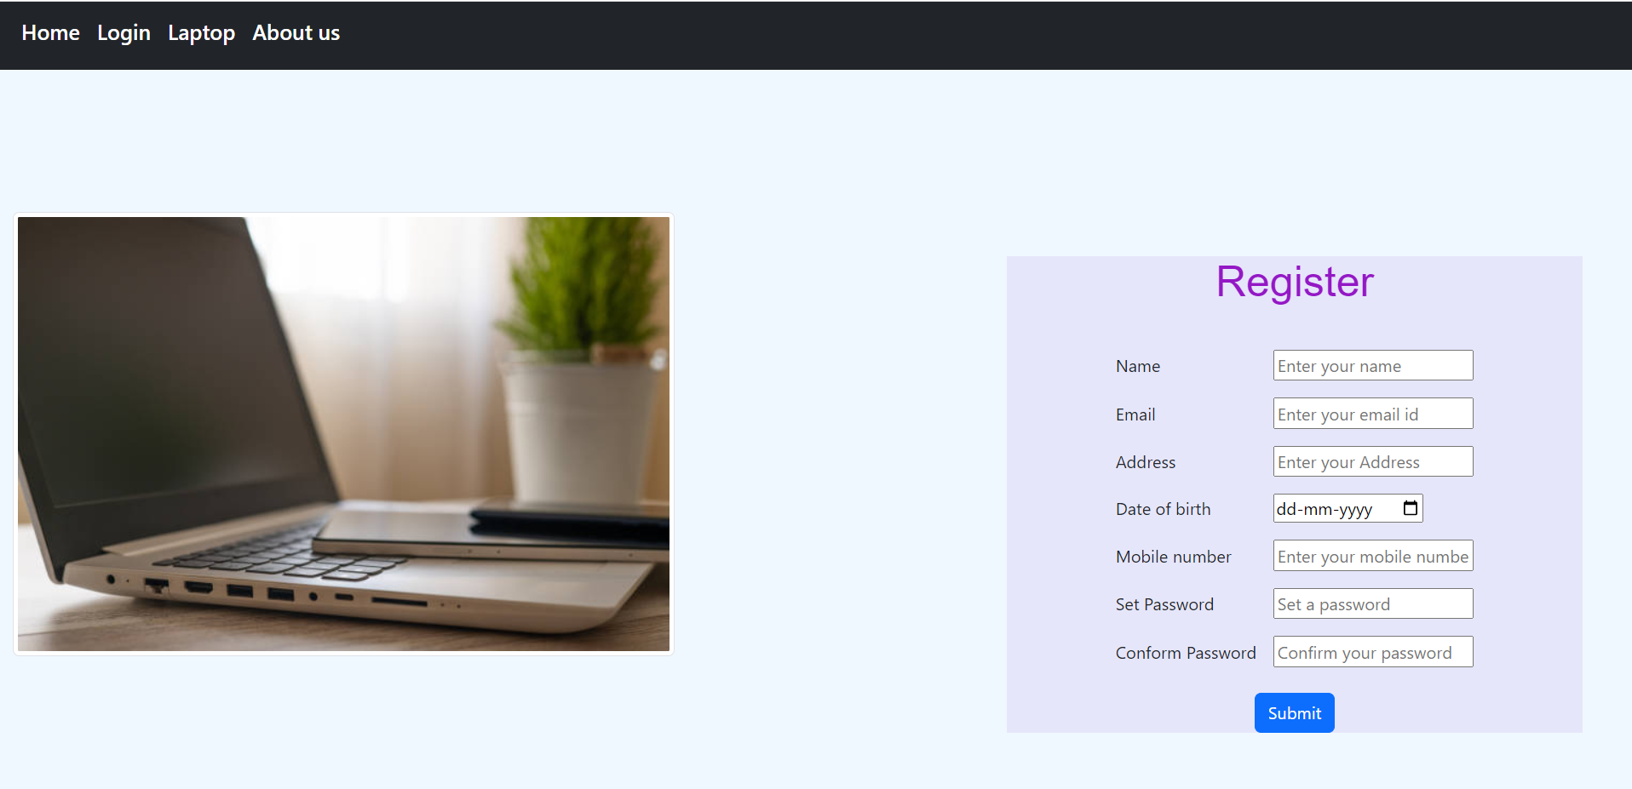

Fig.3.Product page

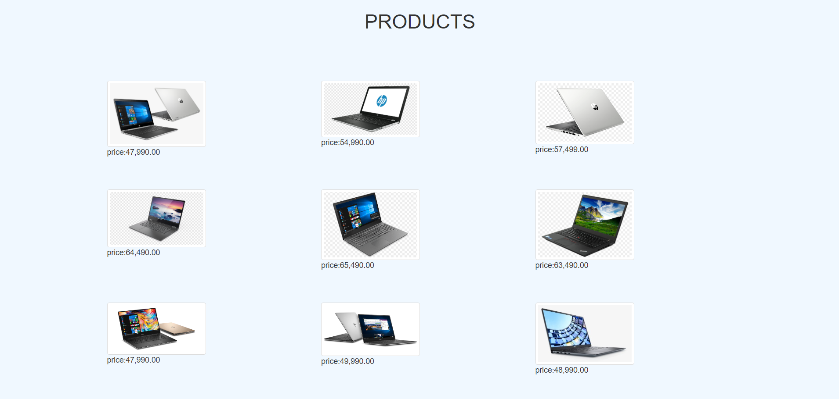

Fig.4.Products detail page

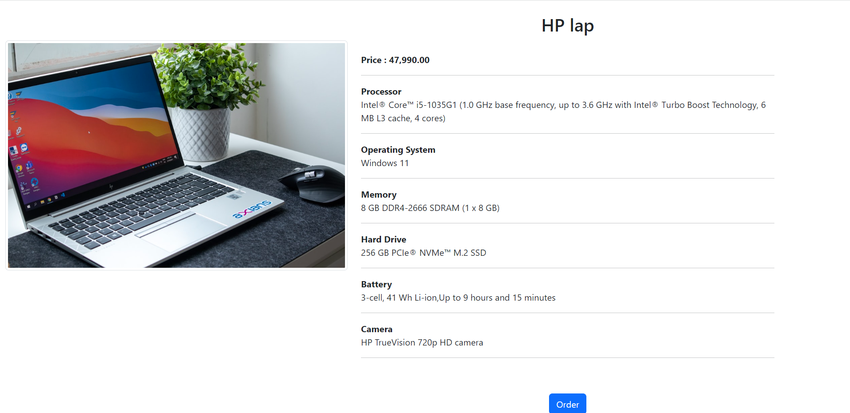

Fig.5.Order page

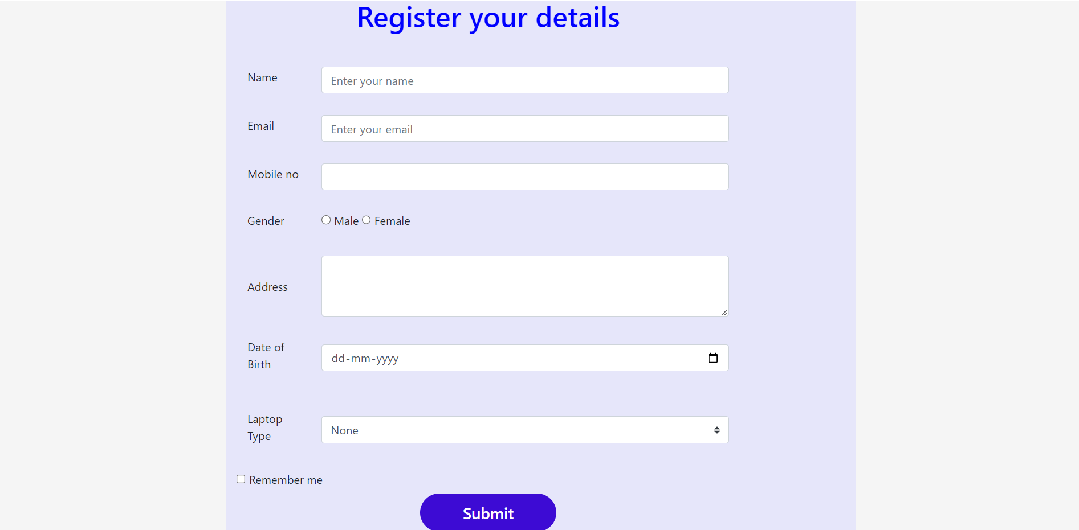

Fig.6.Submission page

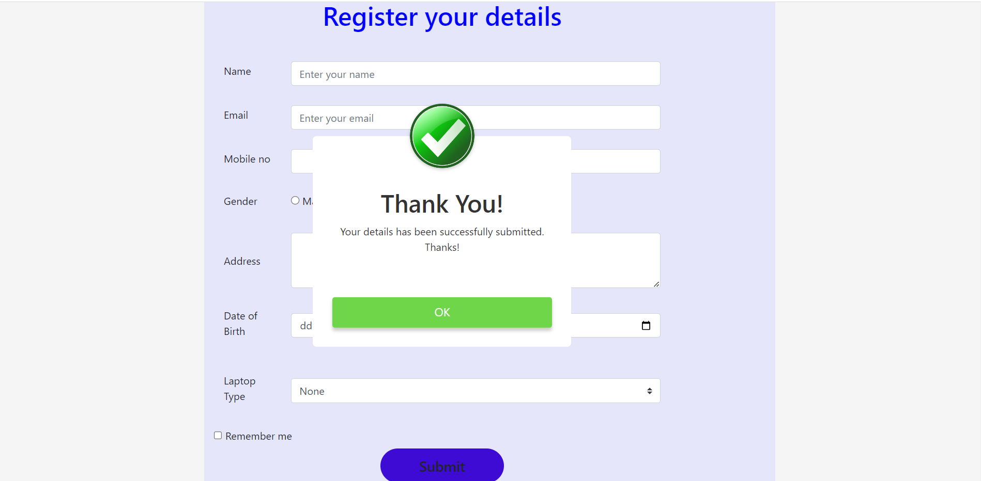

Fig.7.About page

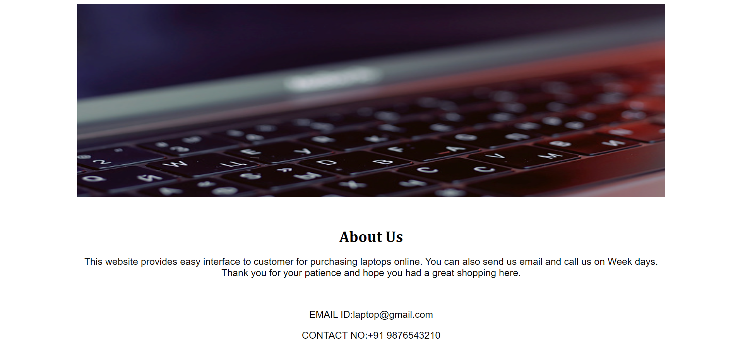

Fig.8.Database connectivity-Mongodb

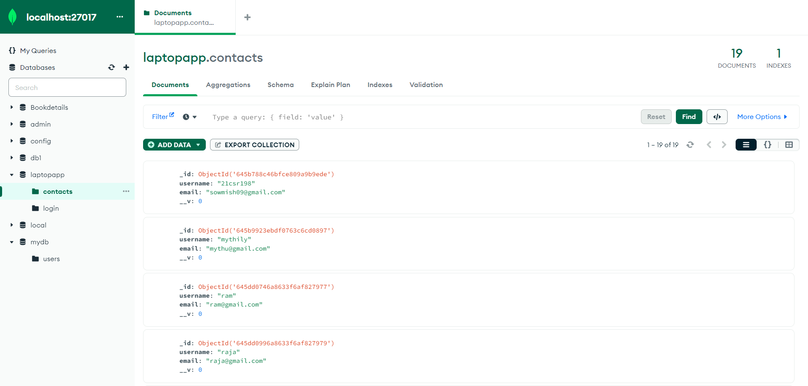

**Result**

Thus the web page for online laptop application was designed successfully.